Page 142
African American Hispanic
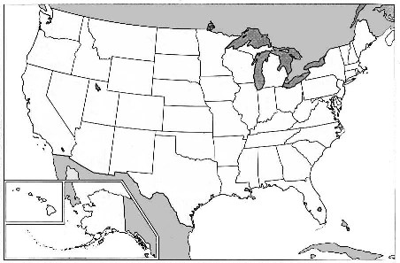
Asian Native American

Natural Resources: draw in natural resources in their home locations: (page 120)
There are over 1000 different religions being practiced in the United States. Draw a Pie Graph listing the % of world religions in the United States. (p. 143)

